LAB-3
Name: v.praneeth
ROLL NO:2303A52146
BATCH: 41

Task 1: AI-Generated Logic for Reading Consumer Details
Scenario
An electricity billing system must collect accurate consumer data.
Task Description
Use an AI tool (GitHub Copilot / Gemini) to generate a Python program that:
• Reads:
o Previous Units (PU)
o Current Units (CU)
o Type of Customer
• Calculates units consumed
• Implements logic directly in the main program (no functions)
PROMPT:
Generate a Python program (without using functions) to read:
- Previous Units (PU)
- Current Units (CU)
- Type of customer (Domestic / Commercial / Industrial)

Validate inputs and calculate units consumed as:
units_consumed = CU - PU
Print all inputs and the calculated units consumed with clear labels.
Add comments explaining each step.

CODE:
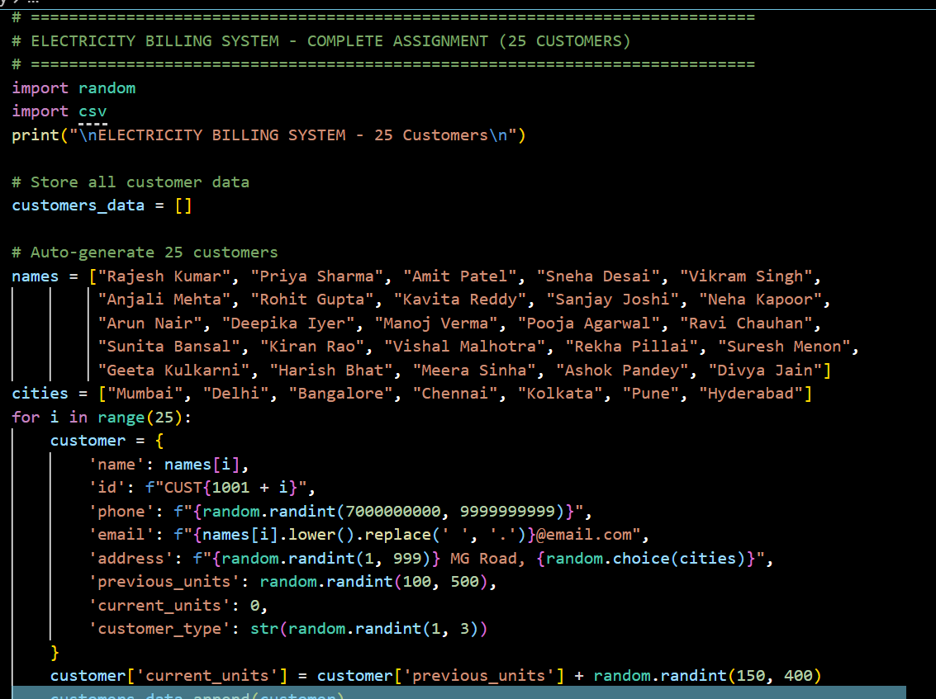

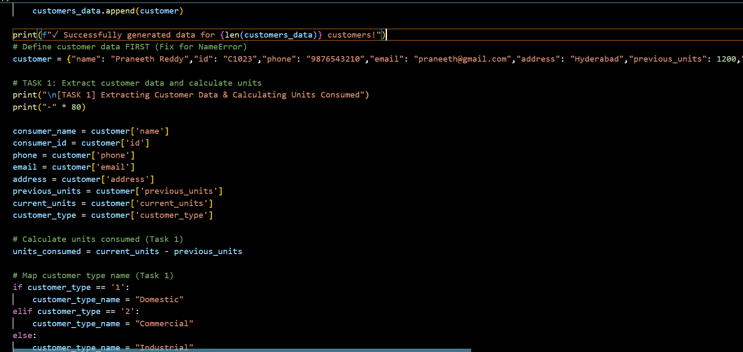
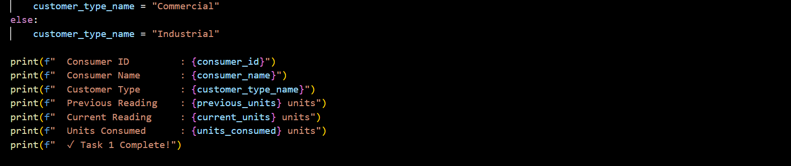
OUTPUT:
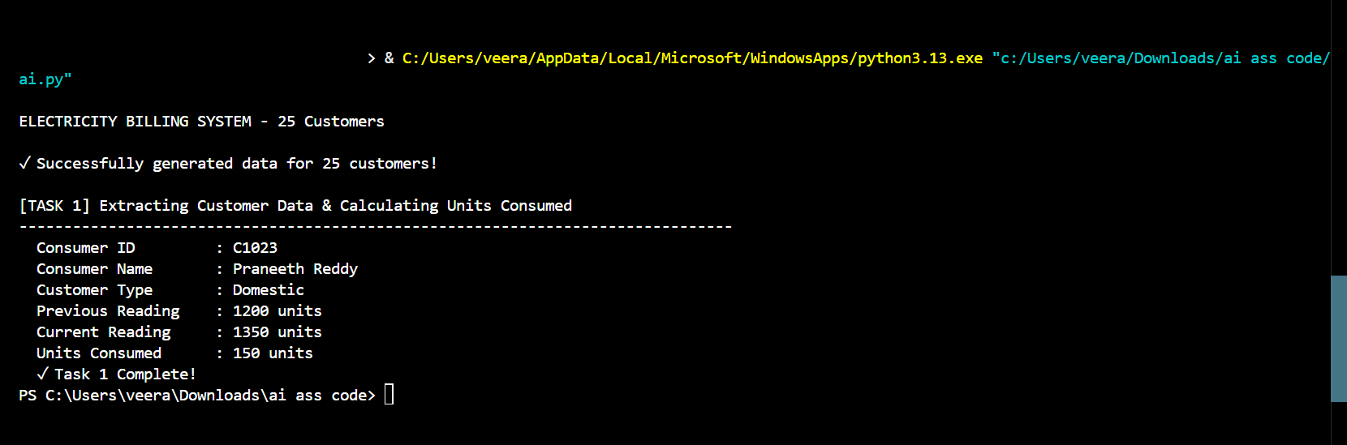
JUSTIFICATION:
extract customer details (ID, name, type, readings) and calculate units consumed using
Units = Current Reading − Previous Reading.
This is necessary because the units consumed decide the tariff slab and are the main input for generating the electricity bill.

Task 2: Energy Charges Calculation Based on Units Consumed
Scenario
Energy charges depend on the number of units consumed and customer type.
Task Description
Review the AI-generated code from Task 1 and extend it to:
• Calculate Energy Charges (EC)
• Use conditional statements based on:
o Domestic
o Commercial
o Industrial consumers
• Improve readability using AI prompts such as:
o “Simplify energy charge calculation logic”
o “Optimize conditional statements”
PROMPT:
Extend the existing Python program to calculate Energy Charges (EC) using conditional statements:
Domestic:
- First 100 units: ₹1.5/unit
- Above 100 units: ₹2.5/unit
Commercial:
- Flat rate ₹4.0/unit

Industrial:
- Flat rate ₹6.0/unit

Use if-elif-else statements and print the calculated EC.
Add meaningful comments.
For logic optimization:
Simplify and optimize the energy charge calculation logic to improve readability.
Ensure the conditional structure is clean and easy for students to understand.

CODE:
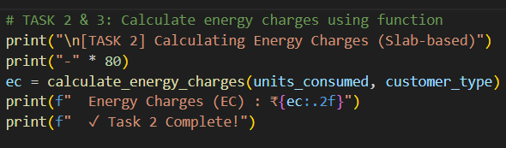

OUTPUT:
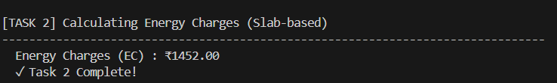
JUSTIFICATION:
performed to calculate the Energy Charges (EC) using slab-based tariff rates based on the units consumed and customer type. This ensures the bill is fair and accurate, since different customers (Domestic/Commercial/Industrial) have different rates and slabs.
Task 3: Modular Design Using AI Assistance (Using Functions)
Scenario
Billing logic must be reusable for multiple consumers.
Task Description
Use AI assistance to generate a Python program that:
• Uses user-defined functions to:
o Calculate Energy Charges
o Calculate Fixed Charges
• Returns calculated values
• Includes meaningful comments
PROMPT:
(Function for Energy Charges)
Rewrite the program using user-defined functions.

Create a function named calculate_energy_charges(units, customer_type)
that returns the energy charges based on tariff rules.
Call the function from the main program.
Add proper comments and sample output printing.
Add Fixed Charges Function)
Add another user-defined function named calculate_fixed_charges(customer_type)
with the following logic:
Domestic: ₹50
Commercial: ₹100
Industrial: ₹150
Return the fixed charges and display them in the main program.
Include comments explaining function usage.

CODE:
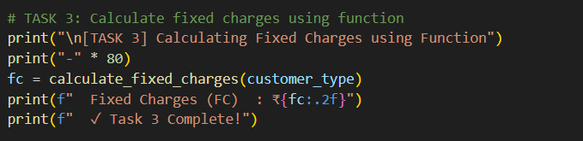

OUTPUT:
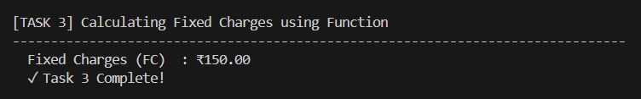

JUSTIFICATION:
to calculate the Fixed Charges (FC) based on the customer type. Fixed charges are added to every bill as a mandatory service/maintenance cost, regardless of units consumed, ensuring correct total bill computation.
Task 4: Calculation of Additional Charges
Scenario
Electricity bills include multiple additional charges.
Task Description
Extend the program to calculate:
• FC – Fixed Charges
• CC – Customer Charges
• ED – Electricity Duty (percentage of EC)
Use AI prompts like:
• “Add electricity duty calculation”
• “Improve billing accuracy
Prompt
Add Extra Charges)
Extend the function-based electricity billing program to calculate:
- Customer Charges (CC) = ₹30 for all consumers
- Electricity Duty (ED) = 5% of Energy Charges (EC)
Print EC, FC, CC, and ED separately with proper formatting.
Add comments for billing accuracy.
Improve billing accuracy by formatting all monetary values to two decimal places.
Ensure calculations are clear and correct.

CODE:
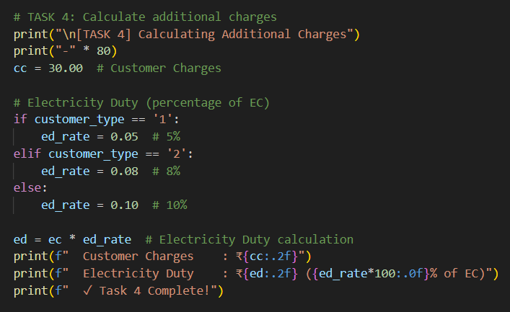
OUTPUT:
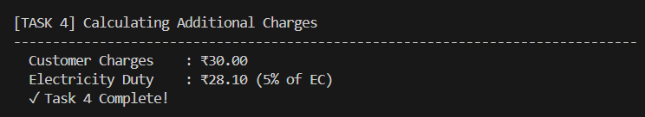

JUSTIFICATION:
to calculate additional mandatory charges like Customer Charges (CC) and Electricity Duty (ED). These charges are required by billing rules, where ED is calculated as a percentage of Energy Charges based on customer type, ensuring the final bill amount is complete and accurate.
Task 5: Final Bill Generation and Output Analysis
Scenario
The final electricity bill must present all values clearly.
Task Description
Develop the final Python application to:
• Calculate total bill:
• Total Bill = EC + FC + CC + ED
• Display:
o Energy Charges (EC)
o Fixed Charges (FC)
o Customer Charges (CC)
o Electricity Duty (ED)
o Total Bill Amount
• Analyze the program based on:
o Accuracy
o Readability
o Real-world applicability
prompt:
Final Bill Calculation)
Generate the final electricity bill by calculating:
Total Bill = Energy Charges + Fixed Charges + Customer Charges + Electricity Duty
Display a neatly formatted electricity bill output similar to a real TGNPDCL bill.
Use clear headings and labels.
Analysis Paragraph for Report)
Write a short analysis paragraph evaluating the electricity billing program based on:
- Accuracy
- Readability
- Real-world applicability
Keep the explanation suitable for a laboratory record.

CODE:
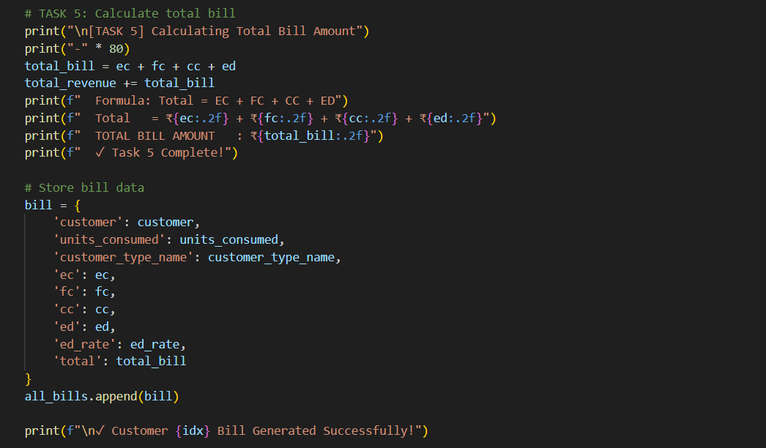
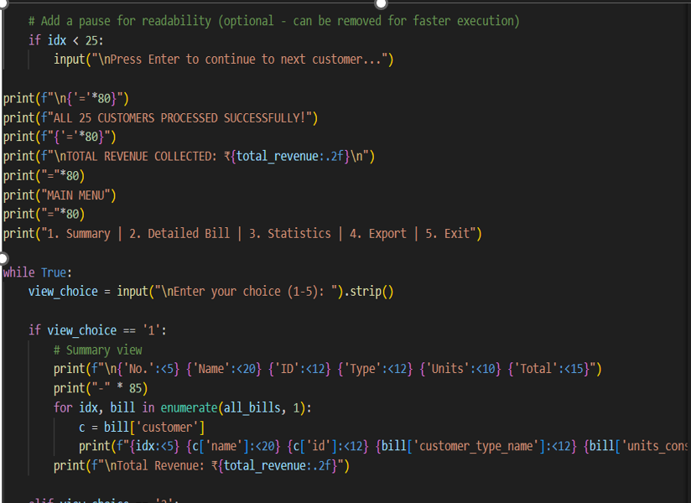

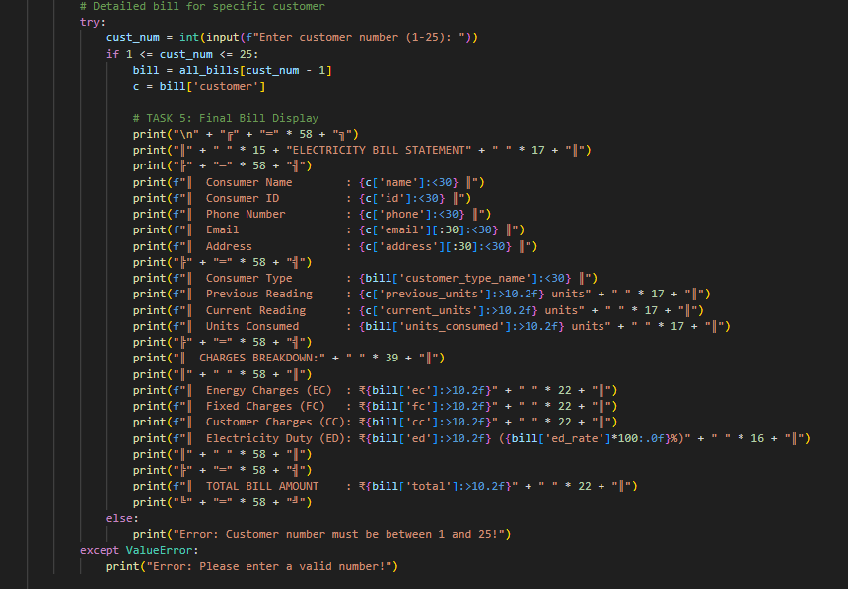
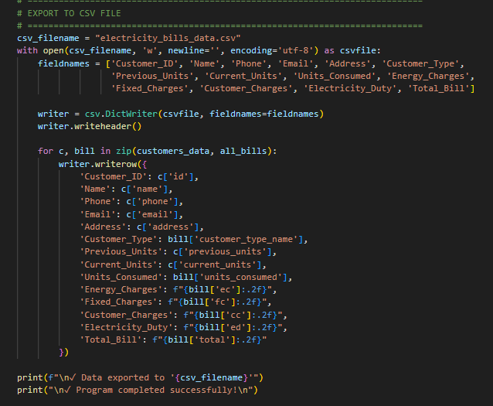

OUTPUT:

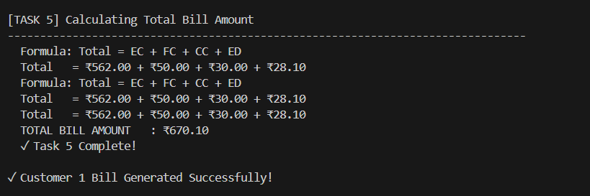

JUSTIFICATION:
performed to calculate the final total bill amount by adding all charges:
Total Bill = EC + FC + CC + ED.
This ensures the customer receives a complete and accurate bill and also helps in computing the total revenue collected from all customers.

